**DAILY ONLINE ACTIVITIES SUMMARY**

|  |  |  |  |  |  |  |  |  |
| --- | --- | --- | --- | --- | --- | --- | --- | --- |
| **Date:** | **04/06/2020** | | | | | **Name:** | **AKASH S** | |
| **Sem & Sec** | **4TH&A** | | | | | **USN:** | **4AL18CS004** | |
| **Online Test Summary** | | | | | | | | |
| **Subject** | | **MICROCONTROLLER AND EMBEDED SYSTEMS** | | | | | | |
| **Max. Marks** | | **20** | | **Score** | | | **18** | |
| **Certification Course Summary** | | | | | | | | |
| **Course** | **ETHICAL HACKING** | | | | | | | |
| **Certificate Provider** | | | **GREAT LEARNING** | | **Duration** | | | **6 HOURS** |
| **Coding Challenges** | | | | | | | | |
| **Problem Statement 1:** **Write a C++ program to find the missing number in array.**  **Problem Statement 2**: **write a java program to read three integer values from the keyboard and find the sum of the values. Declare a variable "sum" of type int and store the result in it.** | | | | | | | | |
| **Status: executed** | | | | | | | | |
| **Uploaded the report in Github** | | | | | **YES** | | | |
| **If yes Repository name** | | | | | <https://github.com/akashacharya786/lockdown-c-coding>  **https://github.com/akashacharya786/lockdown-java-coding** | | | |
| **Uploaded the report in slack** | | | | | **YES** | | | |

Online Test Summary: 18CS45 online test was scheduled from 2:00pm to2:30 am. The portion for the IA was module 3 . The question were MCQ type There were 20 question 1 mark respectively duration is 30 minutes .The score I received was 18/20.

Snap shot:

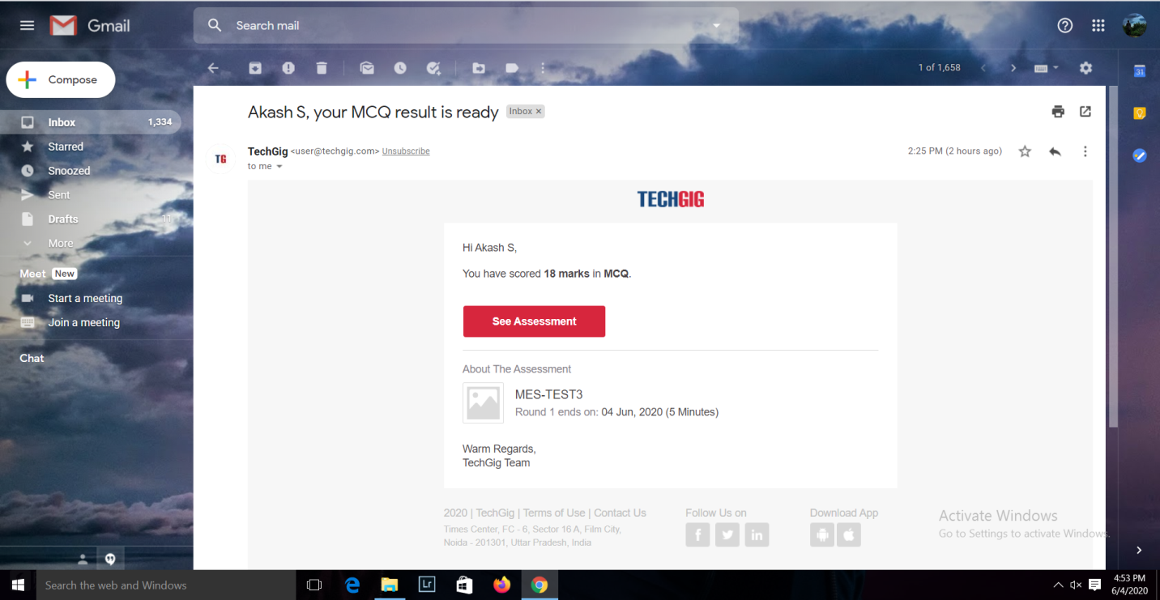

**Online Certification course:**

Today I have started a new course

Name of the course : Ethical hacking

Duration: 6 hours

Certificate provider: great learning

This course contains 6 modules today I completed 3 modules

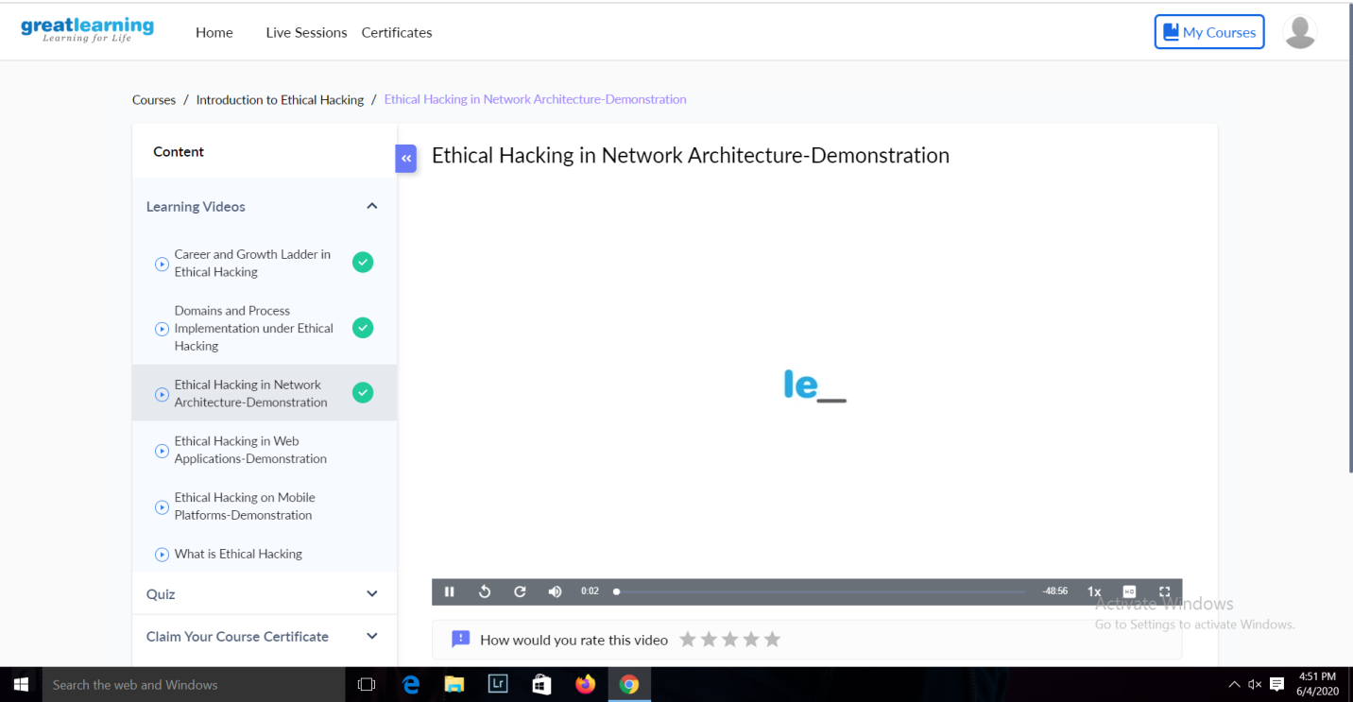

Online Coding summary:

**1. Write a C++ program to find the missing number in array.**

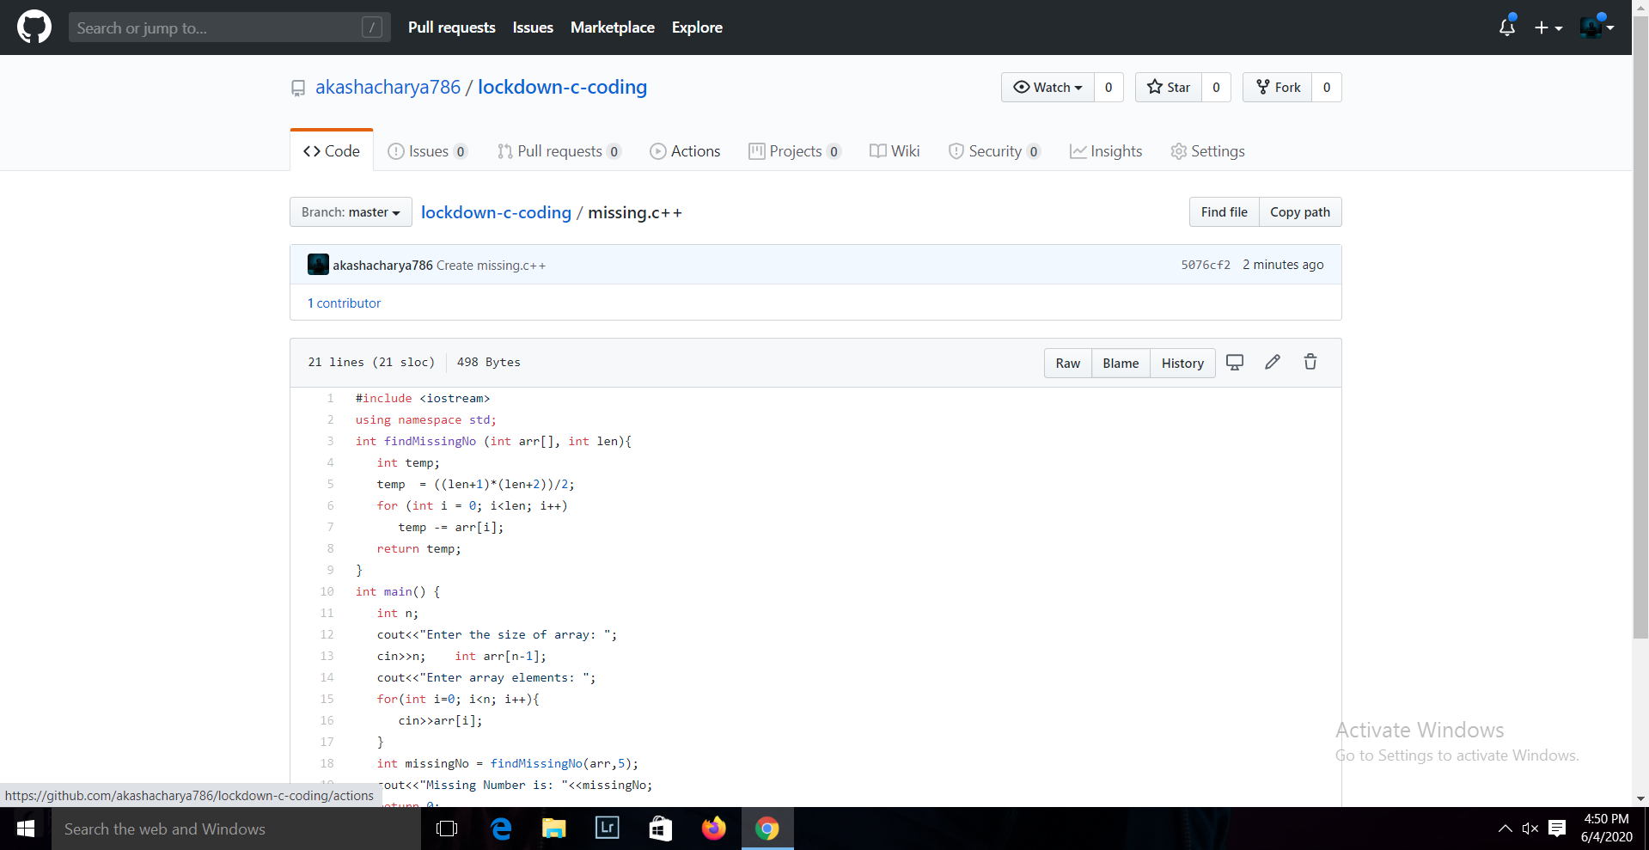

**2. write a java program to read three integer values from the keyboard and find the sum of the values. Declare a variable "sum" of type int and store the result in it.**

